LEAD Project Overview

A significant part of LEAD is to collaborate with an assigned project team to design and implement a leadership project that will directly or indirectly impact the business’s bottom line.

The intent is for LEAD participants to gain experience outside of the classroom in:
- Defining a project, (identify a need, narrow the scope, etc.)
- Learning from multiple stakeholders (establish new relationships, experience the politics, hit walls, etc.)
- Gaining an owner-mindset (champion a project, gain a greater perspective on financials, constraints, etc.)
- Applying the LEAD concepts with their project team.

LEAD participants are challenged to work with their project to select a real-world project to expand their influence in the organization, utilize the skills, tools, and resources they are learning in the workshops, and impact business results.

They adhere to the following criteria:

- Collaborate with assigned LEAD project team members
- Determine an area of particular interest or expertise
- Follow the ADDIE process
- Seek assistance, expertise, insight, and Involvement with stakeholders
- Incorporate best practices from other departments, competitors, and other industries if applicable
- Track wins and key learnings
- Measure business impact
- Suggest next steps for further implementation

They follow the ADDIE process:
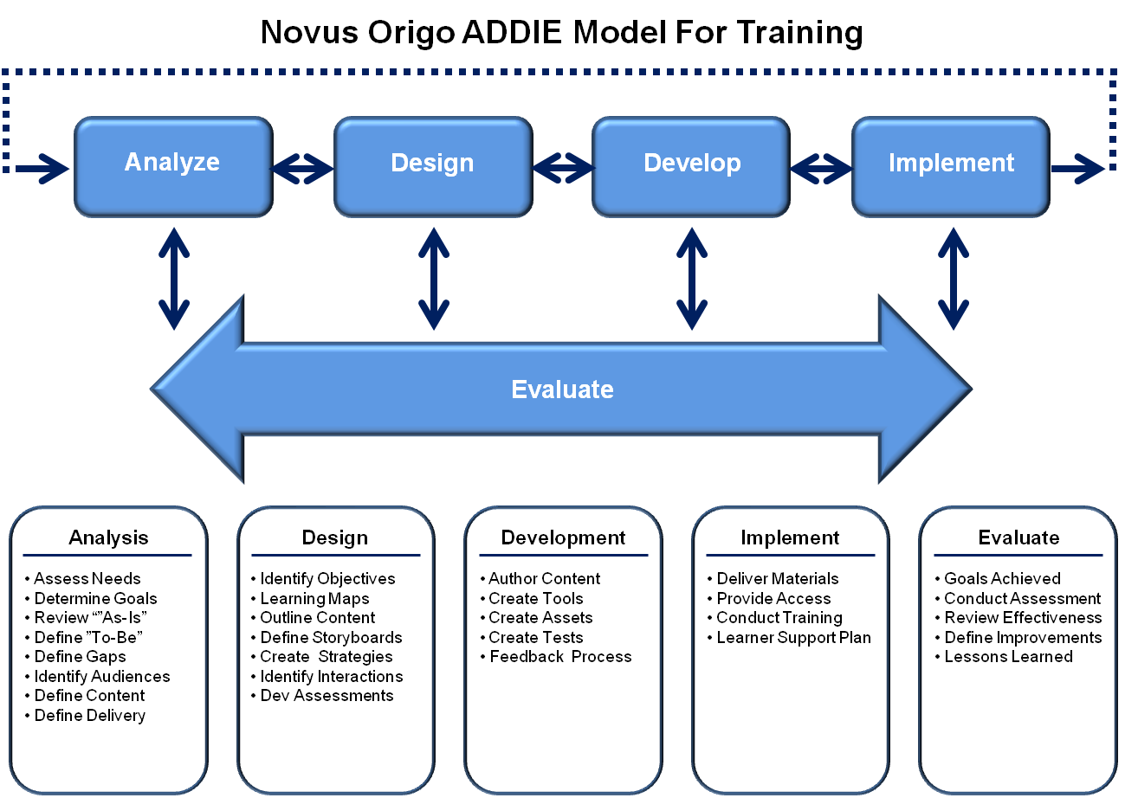

Analysis and Design:
  - Approximately 2-3 months
  - Meet with project team, decide on project focus, scope, requirements, etc, and begin analysis and design, schedule time to pitch idea to senior leadership
Design:
  - Proof of concept presentation to owners: present problem statement, project goal, objectives, action plan, and milestones using the GROW framework (goal (objectives), reality (problem statement), options (what they’ve discovered), and way forward (what they recommend)
Develop and Implement:
  - Approximately 7-8 months
  - Periodically share progress and key learnings and receive guidance and feedback from the cohort
Final Presentation and Recommendations:
  - Team presents the entire project and suggested next steps
LEAD Projects:
Focus, Goal/Problem Statement, Recommendations

Cohort 2022

Project Team: Matt Shem, Flora Garcia, Kristy Attaway, Jeremy Lloyd

Focus: Maintaining culture as the company grows

Goal/Problem Statement: Maintain our small office family culture as H&W continues to grow into a half a billion dollar a year company.

Recommendations: General recommendations using the H&W Way poster.

Project Team: Monica Allen, Scott Max, Mike Yelm

Focus: Creating a service group

Goal/Problem Statement: Our team would like to create a service group that will increase work for our partner companies and maintain relationships with current and past clients. This group will handle every day service needs of clients.

Recommendations: Replace iOffice with the Viewpoint Service Module and a customized, owner interface for warranty and service calls.

Project Team: Matt Sisco, Camille Haley, David Hunt, Craig Wedeman

Focus: Employee lifecycle

Goal/Problem Statement: Streamlining talent attraction, selection, hiring, and integration. An improved, streamlined, well-documented, and consistent candidate search, selection, hiring and integration process to support our “why.”

Recommendations: Leveraged the streamlined process that was already in the works and specifically implemented DiSC which has been used for new hires, project teams, etc.

Cohort 2023

Project Team: Baxter, Ty Walton, Marie Monier, Danny Elmore, Paul Paris

Focus: Improved internal communication

Goal/Problem Statement:
Internal communication at H&W is in need of improvement. Many factors inclusive of changes brought about by the pandemic have created challenges in effectively communicating.

Challenges are associated with internal communication, messaging to external clients, and potential employees.

Recommendations: Greater awareness and involvement in the technology committee. They highlighted Yammer as a better communication tool.

Project Team: Coty Frye, Jeff Sanders, Ryan Shipley, Vanna Rushing

Focus: Recruiting

Goal/Problem Statement:
One of our barriers to successful growth is finding enough of the right people. We believe that clarifying, organizing, and expanding H&W’s recruiting process to create and maintain a talent pipeline will support growth.

Recommendations: Ways to capitalize on referrals and build on what is already working in terms of recruiting.

Project Team: Jared Ricker, Jeremy Rettig, Peyton Boddie, Steve Doyle

Focus: Partner company alignment

Goal/Problem Statement:
Lack of synergy issue between H&W preconstruction & field teams with partner companies creating inconsistent levels of continuity between the groups. This issue creates problems with coordination on both the front-end procurement efforts, as well as field operations creating a successful environment around the partner company teams. This topic was chosen due to it’s continued frustration with executive leadership on the lack of understanding of how this creates more revenue and profit for H&W and the employees who will realize the fruits of the effort.

Recommendations: General recommendations on ways to improve alignment with partner companies through improved communication, relationships, etc.

PC Cohort 2023

Project Team: Bill King, Jeff Harris, Dovee Taylor, Travis Gaber, Jackson Banks, Chad Dunaway

Focus: Bridging the gap with PCs and H&W

Goal/Problem Statement:
To develop the reputation of partner companies as teammates versus subcontractors which will maximize profits for Hill & Wilkinson as a whole.

Recommendations: The team identified actions to build relationships, improve preconstruction processes, and improve project field experience.

- General: Improve understanding and relationships through actions such as attending H&W events, educating H&W on partner company capabilities, having Q&A with H&W teams and leaders during PC LEAD sessions, etc.

- Preconstruction: Improve connection in the earliest stages through actions such as quarterly meetings, open communication, etc.

- Project: Improve field experiences through actions such as feedback, ongoing communication, site visits, etc.

Cohort 2025

Project Team: Prama Kumar, Kyle Marten, Jim Sackett, Jeff Kirk, Jason Ballard

Focus: Constructability reviews

Goal/Problem Statement:
- Proactively identify issues in the documents before construction, resulting in reduced risk, potential cost overruns and schedule delays.
- Move issues from the construction phase back too preconstruction, where they are more efficient to handle.
- Enable the project team to develop risk management strategies as early as possible.
- Conduct a document health check – quality control.
- Truly integrate our preconstruction and field operations teams.

Recommendations: Created a constructability review process and checklist

Project Team: Sergio DeAurojo, Matt Davis, Danny Scoggins, Waylon Minshew

Focus: Collecting feedback throughout the project lifecycle

Goal/Problem Statement:

- Understanding that the end user’s satisfaction is the ultimate goal of each job, it is imperative to gather information during the full construction process from the client. This data will improve H&W’s future success.
- Develop a strategic means to gather client feedback / satisfaction information during construction.
- Create a feedback manual as a tool for both precon and field team members to use across all stages of construction.
- The desire is to apply the data collected for the manual to assist with improvements with project team, better communication with developers/ owners, and setting clear expectations of teams and designers in the future.
- As feedback is collected from the owner, the intent is that this data be gained from face-to-face, sit-down interactions.
- H&W strives to eliminate the “one dimensional” relationship that some clients have expressed with the company.
- Owners should know and feel that they have a relationship with more than just one H&W employee. (Make it more of a team effort so all H&W members on the project engage with the owner.)
- Surveys should be implemented early and at multiple, strategic points in the project (post preconstruction, project mid-point, and project close-out phases) to allow for the most comprehensive feedback.
- An internal feedback process could also be conducted in conjunction to RFP responses (similar to subcontractor inquiries post-bid).

Recommendations: For a future cohort to create a process and manual that included questions for the post-preconstruction, project mid-point, and project close-out

The final presentation is the H&W drive (I do not have access):

https://files.hwgc.com/d/s/126zpjLtTPm7EWCzM7idjCJrW1s05p2c/dPmYIcVOs4OcpfvPpXdqclPaUIRERpYo-RrqARdqHFQw Password: @Wilkinson85

